ADS 3000

Aircraft Detection System

Operation and Maintenance Manual Rev 3.32c
Wilderness Systems and Technologies
Copyright © 2003-2012
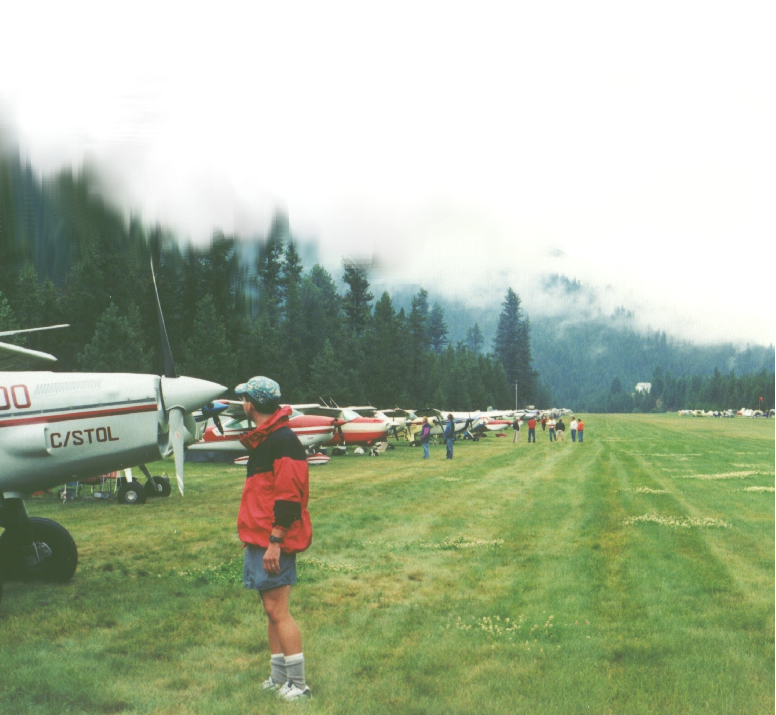

Table of Contents

1. Introduction 1
2. Software Installation 3
3. Physical Installation 5
4. ADS User Interface - The ADS Control Panel 6
5. Alternative User Interface - HyperTerminal 9
6. Precautions 13
7. Troubleshooting 14
8. Specifications 15
9. WARRANTY AND SUPPORT 16
10. ADS IN A NUT SHELL 17

Wilderness Systems and Technologies
3040 W 33 N
Idaho Falls, ID 83402-5326
phone: 208-520-9192
email: support@wildernesstechnologies.com

1. Introduction

The ADS 3000 was designed to provide accurate information on aircraft operations at secondary and backcountry airports. The primary performance+-e objectives are accuracy, low cost, ease of use, and durability. By constantly monitoring acoustic signals and classifying them by amplitude, duration, and seven other features, the system can discriminate between aircraft takeoffs and other sources of sound with an accuracy of greater than 90%.

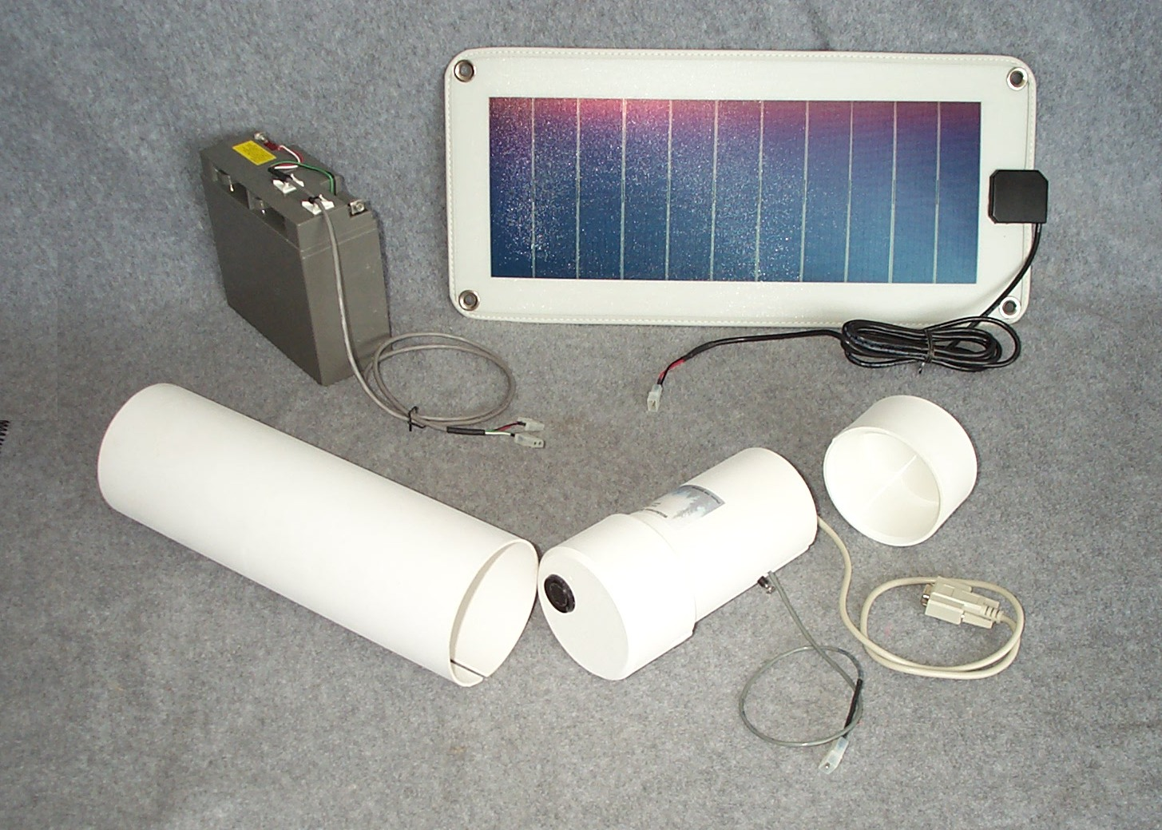
The system consists of a microprocessor and associated electronics packaged in a cylindrical PVC enclosure. An optional battery and Solar Power Option are available. The major components are shown disassembled in figure 1 and assembled in Figure 2.
C
D
Figure 1.

Disassembled, the ADS 3000 major components are:

- Weather Protection Sleeve
- Electronics Package
- Sealed Battery
- Solar Panel
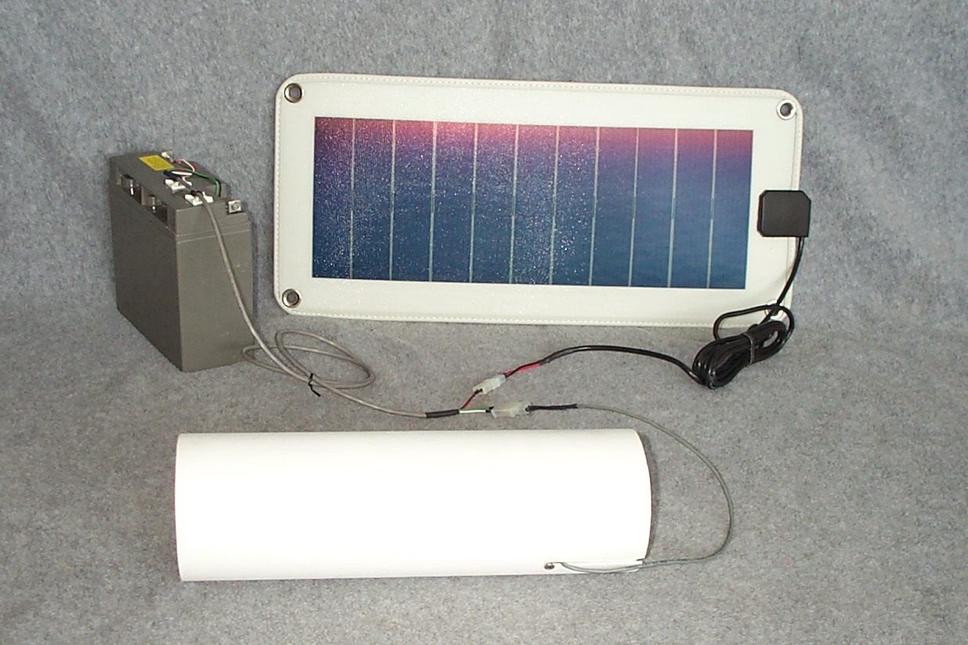
A
B
Figure 2.

When assembled the electronics package slides into the weather protection sleeve. The solar panel and the electronics package power cable can plug into either connector on the battery wiring harness.

ADS operates in either “SENTRY MODE” or “COMMAND MODE”. As the name implies, in SENTRY MODE the system is listening for and analyzing acoustic events to detect the features of a takeoff. If an event meets all the criteria for a takeoff, the time and date are recorded along with the amplitude and duration of the event. In COMMAND MODE, the ADS 3000 responds to operator input to print out its stored data or perform housekeeping functions such as setting the clock. You communicate with the system in COMMAND mode using either the ADS Control Panel or the Windows HyperTerminal accessory.

The ADS 3000 is ready to run with its default settings when delivered. Once you plug in the power, the system starts automatically and runs 24 hours a day until you are ready to download the data. Whenever ADS is powered up, it resumes data collection from where it left off.

When the system is operating on battery power, an LED indicator light on the housing will blink to indicate proper operation. When a signal is being analyzed the LED will stay on. If a unit is being left in the field, the blinking LED is a visible indication that all is well. Note, however, that if a power source greater than approximately 15 volts is used to power the system (as can be the case with AC adapters and solar charging), the LED is always on as the power conserving sleep mode is bypassed.

In summary, the ADS 3000 design is characterized by the following key features:

- Durability – A major design objective was to make both the hardware and software easy to use and tough to break. When installed properly, the specially designed housing is easily concealed and yet protects critical electronic components from snow, rain, and condensation.

- Low Power Requirements - Power to the ADS 3000 is supplied by an external battery (optionally supplemented by a solar cell) or other source that is capable of providing 9-16 volts. An appropriately sized 12 volt battery can power the unit for months at a time even without supplemental solar charging.

- Fault Tolerant Software - Programs and data are stored in non-volatile memory.

- Simple User Interface - A Windows based form is used to download data to an Excel worksheet, set the clock, and reset the count. HyperTerminal, a terminal emulation program that is included with your Windows operating system, can also be used to operate the system and download data in text format.

- Up to 366 daily counts as well as data on the last 3000 individual takeoff events can be stored before the microprocessor will cycle back to write over previous events. This “recycling” of memory allows the system to record the most recent takeoff data while keeping an overall count of the daily traffic for the last year.

- Communication with the counter is through a standard serial port connector on your computer or if no port is available, through a serial to USB converter cable.

- Since ADS is a microprocessor based system it can be easily upgraded. Seven additional sensor channels are available for expansion. With optional software the system can activate a satellite link or phone line, and video, audio, or other auxiliary devices.

2. Software Installation

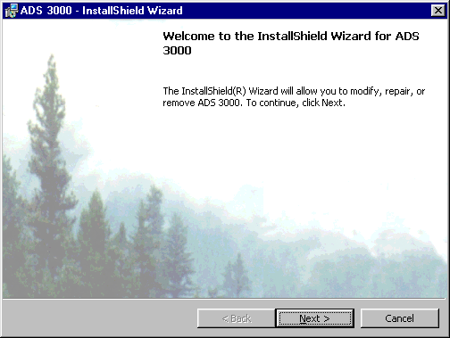
Insert the ADS Installation CD in your CD drive. If Autorun is enabled the ADS installation program will start automatically and take you to a Welcome screen similar to the one shown below. If this does not occur you can start the setup process manually by double clicking or otherwise running the setup.exe program on the CD.

Setup will create a program folder for your ADS 3000 and properly register ADS 3000 with your Windows operating system. If you ever need to, ADS 3000 can be completely removed through "Start" ⇨ "Settings" ⇨ "Control Panel" ⇨ "Add/Remove Programs" or by just reinserting the setup CD to rerun setup.

The default directory for installation is C:\Program Files\ADS 3000, but you can change this to the directory of your choice during setup. When the installation is complete you can start the ADS Control Panel via,

“Start” ⇨ “Programs” ⇨ “ADS 3000” ⇨ “ADS 3000”.

When you start up ADS, Excel may notify you that the file you are opening contains macros and ask if the file is from a trusted source and if you want to enable macros so that it can run. For the ADS Excel software to function macros must be enabled.

The Installation disk shipped with the system contains files in the Utilities directory that are useful in the operation of the ADS 3000. These files are also copied to the ADS 3000 program directory during installation. The file names and their purpose are described as follows:

- ADS HyperTerminal.ht - HyperTerminal File with correct settings.

- ADS to Excel.xls - Excel file to import ADS text data files

- ADS Sample Data Plot.xls - An Excel File containing an example plot

- ADS Test File - Sound of Takeoff.wav -Wave file for system tests

- ADS Test File - Sound of Taxi.wav - Wave file of a taxi for system tests

To use any of these files, double click the file name and the appropriate program should start and load the file.

The HyperTerminal file is included as an alternative communication link to the ADS 3000. If HyperTerminal was installed as part of your Windows setup, double clicking the ADS HyperTerminal file will start a terminal session that can communicate with ADS as described later in this manual. While most users will prefer the graphical ADS 3000 Control Panel to communicate with ADS, the terminal capability can be used if desired or needed.

The ADS to Excel.xls file is an Excel file that contains a macro command for generating a new spreadsheet from ADS data that has been stored in text file format (as in the HyperTerminal log file). When this file is started in Excel, instructions are printed on the screen for running the macro. Using this program to import data into a spreadsheet automates a number of formatting steps required for Excel to manipulate and plot the ADS data.

The sample data plot shows how typical data downloaded from the counter can be plotted to show the number of takeoffs per day as a bar chart.

The two wave files can be played through the user's PC sound system to simulate a takeoff or taxi.

Tip: Quick System Test - A good test of the system, and a quick way to get familiar with ADS is to click on “Show Realtime Data” command In the ADS Control Panel and then play the takeoff.wav or taxi.wav sound in the ADS Utilities folder to trigger the ADS. Each takeoff will be shown immediately in the Realtime Data window (taxis won’t). For an accurate simulation do not adjust the volume control during the playback.

See the section on the ADS Control Panel for more detail on using the Control Panel and Reatime Data display.

3. Physical Installation

A typical installation would be to place the housing 20 to 50 meters from the centerline of the runway at the most likely point of liftoff and opposite from the tie down area.

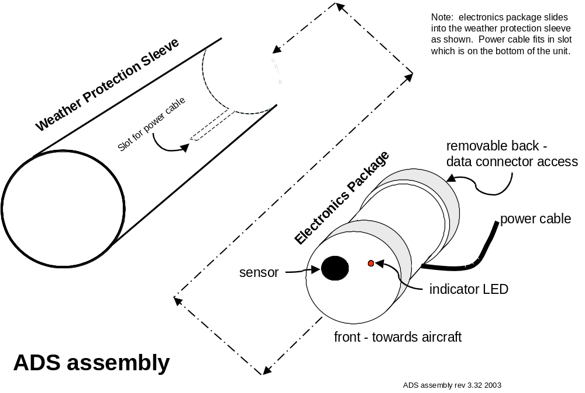
The electronics package slides inside of a cylindrical PVC sleeve that serves as a rain shield. The sleeve should be installed parallel to the ground and out of any depressions that might subject the system to standing water. This can be accomplished by slightly elevating the assembly on some gravel, rocks, or well drained earth so that rain and other moisture will not pool and enter the assembly.

The power cable and guide screw in the bottom of the electronics package slides into the slot in the rain shield. By placing the slot in the weather shield down, any moisture or rain that collects will drain away from the electronics assembly.

Care should be taken to install the housing so that leaves or other debris do not have a tendency to collect in the opening. If necessary a screen can be fitted over the end of the weather shield. The whole system can be concealed if desired, but be sure to not muffle the sensor or create a place where excess water could pool & enter the housing.

If the system was purchased without the battery and solar power recharging option, the wires leading from the housing should be connected to the user supplied power source with the lead marked with a "+" being positive. If the battery/solar option was chosen, the battery and solar panel connections are established with the connectors supplied.

When ready to start the system, plug in the connector on the battery wiring harness to the mating connector on the power cable. Connect the solar panel to the remaining connector on the harness.

4. ADS User Interface - The ADS Control Panel

This section explains the standard method for communicating with the ADS system and accessing data stored in ADS 3000 memory. The instructions in this section assume that the ADS 3000 software has been installed as described earlier in this manual and that the user has Microsoft Office Excel installed. There is also an alternate or backup method of communication using HyperTerminal that is explained in the next section.

To use the ADS interface, first remove power from the ADS 3000 and connect its serial communications cable to the 9 pin COM port on the PC. If a serial port is not available use a serial to USB converter cable. After connecting, reapply power to the ADS 3000.

Now start up the user interface via:

Start ⇨ Programs ⇨ ADS 3000 ⇨ ADS 3000

Enable Macros if you are asked to do so by Excel. This will bring up an Excel worksheet that can activate the ADS Control Panel as shown in the following figures.
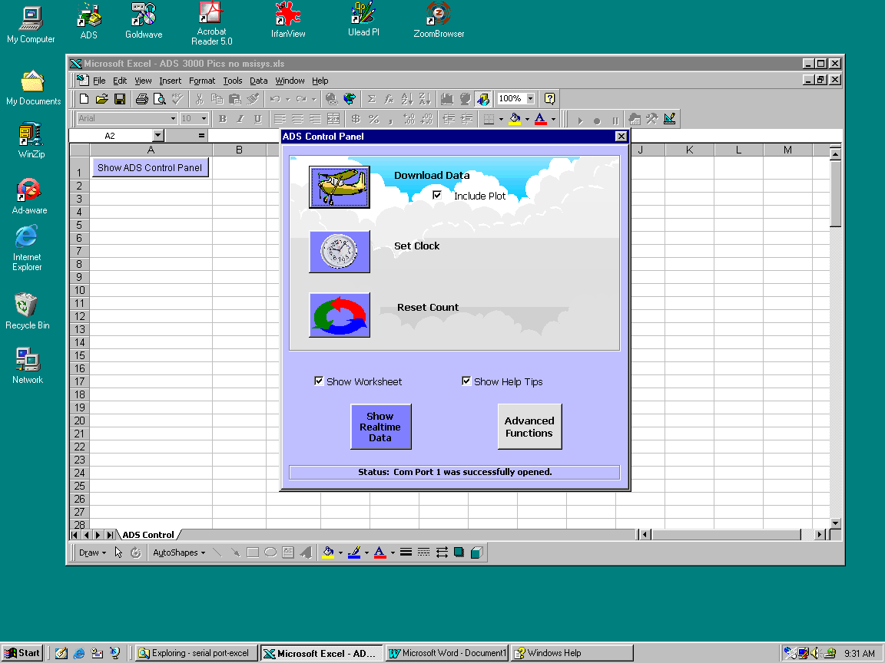
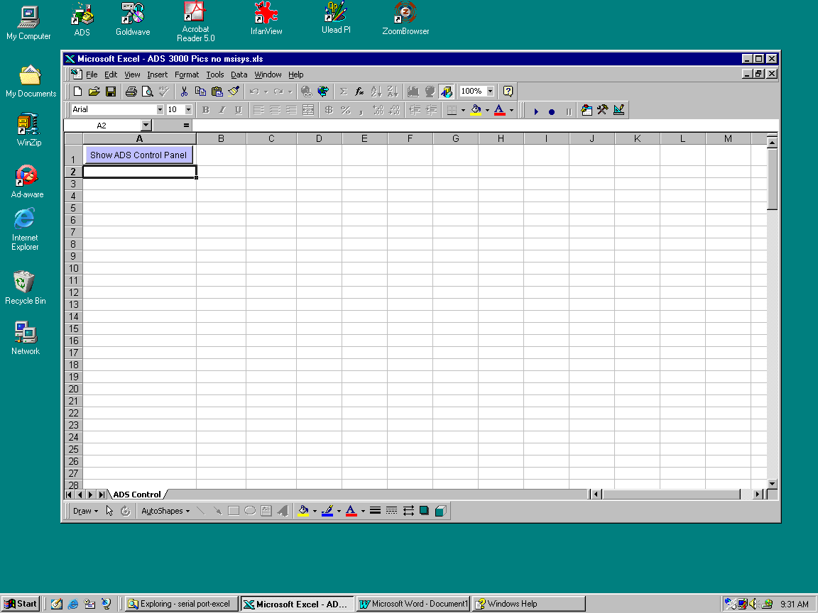
Click the “Show ADS Control Panel” button to bring up the ADS Control Panel.

The ADS Control Panel pops up and attempts to open the serial port on your PC. The status message indicates if it was successful.
USING THE 3 ADS CONTROL PANEL SCREENS
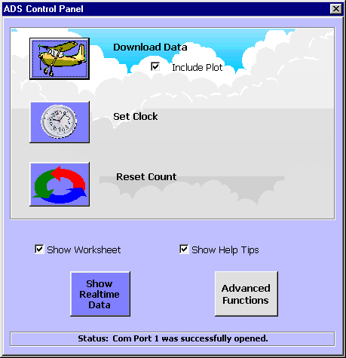
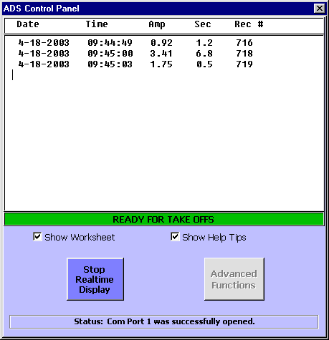
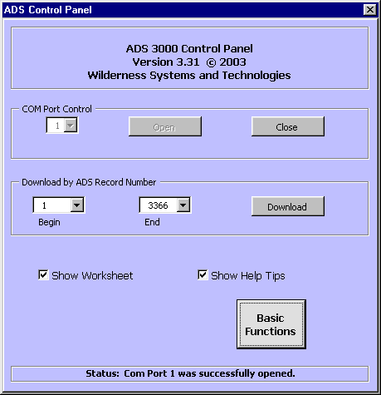
Basic Functions allow you to download & plot data, set the ADS clock, and reset the takeoff count.
Worksheet & Tips Options
Access Real-time Data and Advanced Functions Screens
Com Port Status
Real-time data displays each takeoff as it occurs. The green “READY” bar must be visible to show that ADS is ready for new data & not busy analyzing incoming data.
Advanced Functions allow direct access to COM Port controls, and the downloading of specific ADS data memory records.
When you are done downloading data, close the Control Panel window and you will be in the new worksheet opened to accept data. If you checked the “Include Plot” checkbox, your screen will look similar to this:
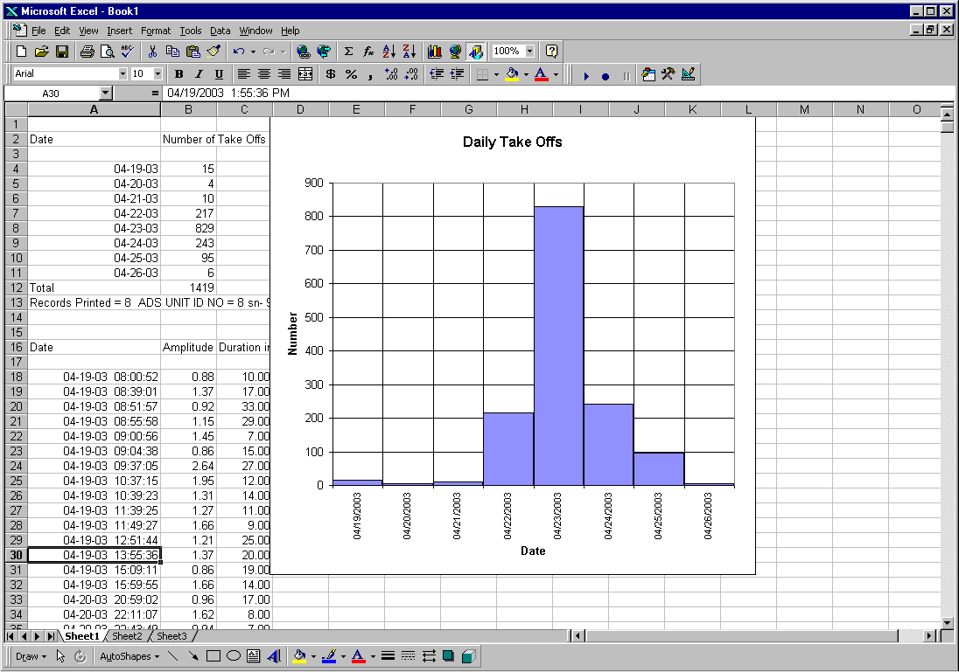
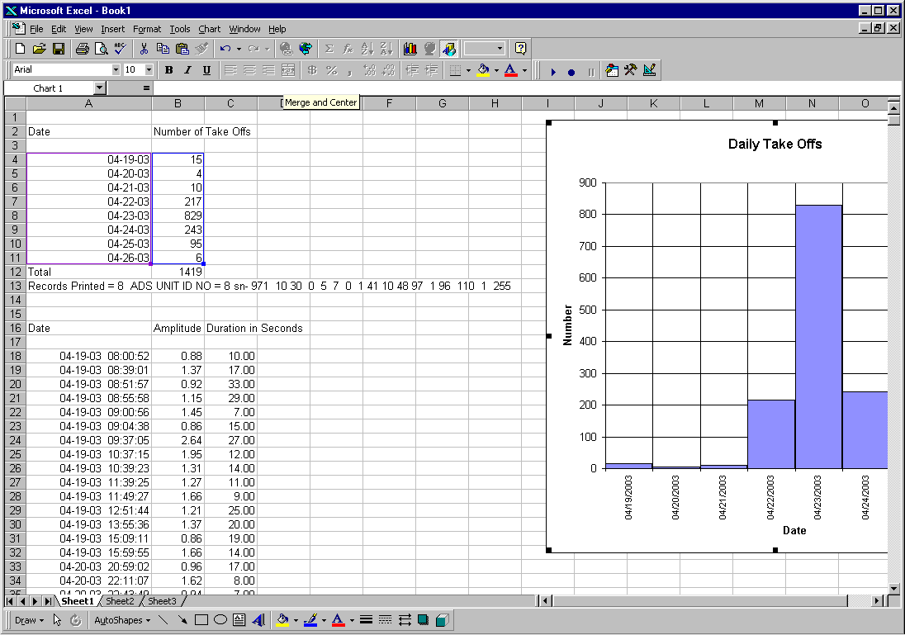
Click & drag the plot to the side if necessary (see figure below), and you will see that the first group of data (rows 1-13 in this figure) contain the daily count totals for all takeoffs. The remaining rows contain details on the individual takeoffs. The last line of each data group lists the number of ADS records downloaded as well as the “UNIT ID” number, which is made up of the unit’s serial number and analysis parameters.
For the individual takeoff data, the number in column B is the relative amplitude or loudness of the event. The number in column C is the approximate time in seconds that the takeoff lasted. This information is often useful for characterizing the takeoff and verifying system operation.

If you prefer a less colorful interface, you can change to the “Classic” ADS interface which has all ADS functions on a single form with no pictures as described below.

The Directory you chose for installation when setting up ADS will contain the three Excel files:

ADS 3000 Pics.xls
ADS 3000 Classic.xls
ADS 3000 CP.xls

Each file provides a specific style of interface to your ADS 3000 counter. The default interface is "ADS 3000 Pics.xls", and this is the file that will used when you start ADS 3000 through the start menu. You can, however, use any of the three files as your interface to ADS 3000 as they are functionally equivalent. The one you choose to use is a matter of personal preference. "Pics" is more of a graphical interface, "Classic" is a more traditional Windows form with all functions displayed on one page, and "CP" lets you select which interface to use each time you start up ADS.

You can designated which interface you want to use by replacing the default shortcut to "ADS 3000 Pics.xls" in the Windows\Start Menu\Programs\ADS 3000 folder with a shortcut to the file you want as the default. Alternatively, you can create a shortcut to any of the three files on your desktop and use this shortcut to start up the ADS interface.

5. Alternative User Interface - HyperTerminal

There may be times when you choose to communicate with ADS using a terminal program such as HyperTerminal. This was the original ADS interface and its functionality has been maintained in newer ADS versions as a backup interface and also to perform some specialized maintenance functions should they ever be needed.

To access this alternative communication capability, first disconnect power from the ADS 3000 and plug in its serial communications cable to the 9 pin COM port on the PC. Reapply power to the ADS 3000.

Next, you will need to start up HyperTerminal on your PC. HyperTerminal is one of the accessory programs that is usually installed on a typical Windows system. The easiest way to start a HyperTerminal session is to go to,

Start ⇨ Programs ⇨ ADS 3000 ⇨ Utilities⇨ HyperTerminal

After starting HyperTerminal, it is recommended that you open a session log file to capture a record of the data. A log file will record all the information shown on your screen during your session as a text file that can be used for later analysis. You can create the log file by using,

Transfer ⇨ Capture Text ⇨ …(then select or name a file)

NOTE FOR THE EXAMPLES THAT FOLLOW:

Boldface Text – indicates text messages from ADS

Yellow Highlighted Text - indicates operator input to the ADS 3000 system. All inputs except for the wakeup key "/" assume that the “enter” key is pressed after the input.

Once you have the terminal session running, let the system know that you’d like it to wake up from SENTRY MODE and enter COMMAND MODE. This is done by holding down the " / " key until you see the response below in the Hyperterminal Window.

THE ADS SYSTEM IS READY TO ENTER COMMAND MODE.......
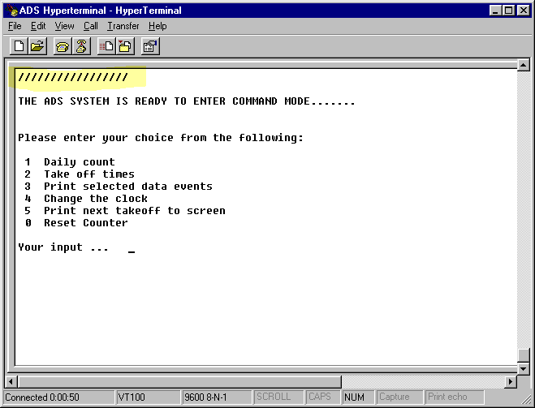
Release the " / " key and the system prints the following menu:

Entering “1 ”, will print out a daily summary count for all days of operation since the last reset command.

Entering "2 ", automatically prints out all data from the first event through the most recent event since the last reset command. If more than 3000 events have been recorded since a reset, the printed events will only be those that have occurred after the 3001st event “rolled over” and was stored in the first memory location.

Entering “3 ”, allows you to specify which events to print from 1 to 3366. This is useful if you have a need to view specific segments of the currently stored data. For example if the memory storage has rolled over or you need to see some old data after resetting the counter, this command can be used to examine any portion of the 3366 memory locations. You will be prompted to enter the first and last locations you want to print out.

Entering “4 ”, brings up a set of submenus to set the internal clock of the ADS 3000 microprocessor. You will need to enter the day of the week, year, month, day, am/pm, hours, minutes, and seconds.

Entering “5 ”, tells ADS to print the next takeoff to screen in addition to storing it in memory. This option allows one to easily verify in the field if a takeoff has been detected and saved. Note that the data printed out in this mode is not formatted, but it does contain the date and time, amplitude, and duration as well as other analysis parameters. Only one takeoff will be printed from this mode before reverting to normal operation. To continue observing takeoffs in realtime, you must reenter the menu.

Entering “0 ”, resets the counters to zero, and provides the option of changing the default analysis parameters. After a reset, data stored in ADS will be written over.

For example, entering “2” to print out the date and time of recent takeoffs would generate a dialog similar to that shown here:

Please enter your choice from the following:

1 Daily count
2 Take off times
3 Print selected data events
4 Change the clock
0 Reset Counter

Your input ... 2

Date and Time of Takeoffs for sn 987 AMPLITUDE SECONDS

12 / 29 / 2001 10 : 52 : 2 , 2.30 , 16
12 / 29 / 2001 11 : 24 : 2 , 3.36 , 25
12 / 29 / 2001 11 : 54 : 22 , 1.30 , 10
12 / 29 / 2001 13 : 55 : 2 , 4.26 , 14
12 / 29 / 2001 19 : 59 : 56 , 0.87 , 17
12 / 30 / 2001 7 : 0 : 16 , 4.21 , 19
12 / 30 / 2001 7 : 2 : 57 , 2.91 , 15

ADS HAS RETURNED TO SENTRY MODE - HOLD DOWN THE '/' KEY TO WAKE

Copyright 2002-3, Wilderness Systems and Technologies

The current system configuration code is:
16 31 0 50 6 0 25 33 10 48 97 1 0 110 1 255

The number in the first column after the date and time is the relative amplitude or loudness of the event. The number in the next column is the approximate time in seconds that the event lasted. The relative amplitude and duration in seconds can be used in a general way to characterize the event and verify system operation.

When all the requested data is printed, ADS prints the message that it has returned to SENTRY MODE, the copyright message, and the system configuration code which uniquely identifies which ADS 3000 sensor was used to collect the data.

It should be noted that while waiting for operator input in COMMAND MODE, the ADS system is not available for counting takeoffs. After data is displayed on the screen though, the system automatically goes back to SENTRY MODE. To reenter the COMMAND MODE, simply hold down the " / " key again until you get the COMMAND MODE message.

Data that has been printed on the PC screen or recorded in a log file can be highlighted for copying and pasting to other applications such as Notepad or Word where it can be saved as a separate file on disk. If you are copying data from the screen by cutting and pasting to another application, it is recommended that the file you create be saved as a text file.

Once you have saved your data in a text file either by using the session log file function of HyperTerminal or by cutting and pasting, you can import the text data into a spreadsheet such as Excel. The Demo disk that came with your shipment contains an Excel file named, “ADS to Excel.xls”. If you double click this file to open it, you will be taken to an Excel worksheet that automates the import function using an Excel macro. Follow the instructions shown on the screen and a new spreadsheet will be opened with your ADS data properly formatted for use in Excel.

TIP: Setting the Correct COM Port Number – Both ADS user interfaces communicate through one of your computer’s “COM” ports. To find out which COM port number should be used with ADS, navigate the Microsoft Windows Control Panel to open the “Device Manger” window. Click on the “+” by the “Ports (COM & LPT)” line to display which port numbers are available or in use. If you are using a serial to USB adapter it will also be listed in this section. Note the number of the port which is connected to the ADS cable and use that to set the correct port number in the Excel or HyperTerminal interface.

If you need additional assistance, please don’t hesitate to contact us.

6. Precautions

- Do not leave the system in the field without the weather shield installed. The outer sleeve weather shield is important for both protecting the electronics from excessive moisture and providing a specific geometry for accurate counting.

- Be sure that the ADS 3000 is installed with its cylindrical axis parallel to the ground, approximately level, and the slot down. Do not tilt skyward as this will expose the system directly to rain and it does not provide any improvement in sensitivity.

- For maximum accuracy install the system 50 to 150 feet away from the runway centerline and in a location away from aircraft warm up and parking areas. Ideally the best location(s) will maximize takeoff noise as compared to ground operations or low level flyovers.

- Even low voltage solar cells or charged batteries are a potential hazard, and significant heat and sparking can be caused shorted connectors or off-normal conditions. If desired, the battery can be placed in a protective enclosure. The standard battery & wiring harness are designed to fit into an army surplus ammunition box as one option.

- The electronics module located inside the sealed housing contains the microprocessor, and electronics for power, signal conditioning, and communications. There are no user serviceable parts inside and opening the case will void the warranty and likely result in degraded performance. Please contact Wilderness Systems and Technologies for service.

- Avoid static electricity build up and direct contact with connector pins.

- ADS was shipped with default settings that are optimized for a typical general aviation, backcountry airport, but other analysis parameters can be entered when the system is accessed with the HyperTerminal interface and placed in COMMAND MODE. While modifying the default analysis parameters can provide a great deal of versatility in counting specific types of events or in adjusting to unusual local conditions, it is highly recommended that the user consult with Wilderness Systems and Technologies before changing the defaults. If the analysis parameters are changed, the system will continue to use those parameters even after a reset.

- If the analysis parameters are ever inadvertently changed while working in HyperTerminal (they can’t be changed from the ADS Control Panel), you can reset them to the factory defaults by performing another reset and entering the following numbers when prompted for new analysis parameters,

.23,50,0,16

7. Troubleshooting

Problem | Check the following
LED does not light up or does not flash when power is applied | - Power source connection defect. Check connectors  - Low battery charge  - Bright sunlight obscuring LED
When you start the ADS Control Panel the status message says it was unable to open the COM port | - Another device may be using the COM port or the port is disabled. If the PC you are using is on a network, you may need to contact your network administrator to help configure your COM ports to work with the ADS 3000.  - The default port number ADS opens on startup is incorrect. Try opening another port number. If the port number change is successful in downloading data, the new port becomes the default.
ADS does not respond to commands even though the status message says a COM port was opened successfully. | - No power or the system is the ADS 2000 version  - ADS may be connected to the wrong port. Try changing the COM port number in the ADS Control Panel. As the factory default, ADS attempts to open COM 1 on start up. If that is not the port connected to the ADS 3000, you can use the COM port commands to change to another port number.  - ADS may be analyzing background sounds and can’t respond until there is a fraction of a second of quiet.  - Especially noisy electrical environment. Move or shield ADS electronics package from source.
After a period of normal communications, there is no response. | - There may have been an timing error in the communication link. Cycle power to the ADS system, restart Control Panel and retry the command.
A visually observed takeoff was not counted by ADS | - Check that outer weather shield tube is installed  - Two aircraft taking off within 20 seconds of each other may not register if the sound levels are high.  - Check for LED flash – temporarily disconnect solar panel if necessary to drop supply voltage.  - System location – move next to the typical liftoff area.  - Try again. A > 90% accuracy does imply that a small percentage of “atypical” takeoffs may not register.
You get an error message while using the ADS Control Panel that starts with, “Please Contact WST …” | - Restart the ADS Control Panel and recycle power to the counter. If problem persists, contact Wilderness Systems for assistance. These messages help us track down the source of problems you might have with your specific setup.
“I still have a problem …” | Contact us - you have full, no cost support privileges

8. Specifications

ADS 3000 operates by analyzing acoustic signals for characteristic features that identify a specific type of event. Analysis is performed using an embedded microprocessor with real-time clock and analog to digital converter, signal conditioning electronics, and nonvolatile data memory. For aircraft detection, the system software is normally set up to detect the sounds associated with an aircraft takeoff. If a signal is detected and meets the analysis criteria, the microprocessor notes the time and date, and stores the event in memory. In addition, a running count of the number of takeoffs each day is stored separately in data memory. When needed to conserve power, the ADS system is set to “sleep” for 2 second intervals. At the end of each sleep interval the unit wakes up to sense for signals of interest.

Data storage characteristics (standard configuration):

Number of days that can be stored before recycling memory 366
Number of individual takeoffs stored before recycling memory 3000

Takeoff count accuracy >90% (+/- 10% of true count)

Time record accuracy +/- 2 seconds

Communications:

Hardware specification RS 232 serial port – 9600 baud,8,1,none
Software specification ADS 3000 Control Panel or HyperTerminal

Operating/(storage) temperature -10°C to 60°C/(-40°C to 85°C)

Power requirements 7-16 VDC, 70 ma peak, 17 ma sleep

Physical description:

ADS 3000 housing Cylinder - 108 mm dia, 210 mm length
Solar Power Option, 5 watt panel panel, 358 x 333 x 25 mm or similar
Solar Power Option, battery 12 volt sealed lead-acid battery

9. WARRANTY AND SUPPORT

The ADS 3000 system is warranted by Wilderness Systems and Technologies against defects in materials and workmanship for two years from the date of purchase.

Furthermore, if the ADS 3000 system does not meet your expectations for any reason within the first year after receipt, you can return the system and receive a full refund.

This warranty excludes damage caused by neglect or improper use of the equipment, and incidental or consequential damages. The system must be returned to Wilderness Systems and Technologies for warranty repair.

Some states do not allow certain conditions on the repair of warranted products, so these conditions may not apply in those cases. The forgoing warranty is the only warranty with respect to this product and no other warranty, express or implied, is made.

Warranty inquiries or requests for technical support should be directed to:

Wilderness Systems and Technologies
3040 W 33 N
Idaho Falls, ID 83402-5326

phone: 208-520-9192
email: support@wildernesstechnologies.com

Wilderness Systems and Technologies welcomes your suggestions for product improvements and service. Please contact us if you experience any difficulties in using this system. We stand behind our products.

10. ADS IN A NUT SHELL

The following steps provide a quick overview of how to set up and use the ADS 3000 Aircraft Detection System. The complete Operation and Maintenance Manual can be downloaded from the Wilderness Systems and Technologies web site at www.wildernesstechnologies.com

- Unpack the shipping box and verify that it contains the following components

- ADS 3000 cylindrical housing and weather shield
- If purchased with the solar power option the shipment will also include an AC adapter, solar panel, and sealed rechargeable battery with wiring harness.

- To familiarize yourself with the system’s operation, reconnect the + terminal of the battery (removed for shipping) to the wiring harness. Apply power to the system by plugging in the connector on the harness to the mating connector stored in the back of the ADS housing. Once connected, the LED indicator light at the front of the housing will blink whenever the system “awakes” to analyze data. It will stay illuminated if you blow or whistle into the sensor. Note that the LED will not blink when powered by sources higher than the 12 volt battery. This can be the case with solar power charging and AC adapters. Disconnect the power.

- If not previously installed, install the ADS software per the instructions on the CD.

- Remove the cap at the back of the housing to access the data cable. The data cable can be plugged into the 9 pin serial port on the PC while the PC is on or off and the counter is not powered up.

- Start the ADS Control Panel via “Start” ⇨ “Programs” ⇨ “ADS 3000” ⇨ “ADS 3000”.

- Apply power to the system. The AC adapter or battery can power the system while it is connected to the PC. Click the “Show ADS Control Panel” button to show the Control Panel.

- Click any of the command buttons in the ADS Control Panel to perform the labeled function (i.e. “Set Clock”, “Download Data”, etc.). One good test is to click on “Show Realtime Data” command and then play the takeoff.wav sound in the Utilities directory to trigger the ADS.

- When done, disconnect the power cable and close the Control Panel.

- After Closing the Control Panel, you will be in the last worksheet to receive data from your ADS session. Save or delete the data worksheet to return to the spreadsheet with the “Show ADS Control Panel” button.

- To install the ADS 3000 in the field, first survey the runway to evaluate the best location to install the system. Typically this will be at the point where lift-off occurs. The best location is one that maximizes the sound of a take off and minimizes any other sounds such as taxis and warm ups.

- Place the cylindrical axis of the ADS assembly (instrument package and outer weather shield ) on the ground horizontally to allow for drainage during rainstorms or irrigation. The assembly should not be installed vertically or at an angle as this may subject the system to excessive moisture. The slot for the power cable should be placed down to drain any rainwater or condensation. Rocks or other natural cover can also be placed on top the housing for concealment or stability if desired.

- Locate the battery and solar panel near the housing with the solar panel facing south and tilted towards the sun. Tie down or otherwise retain the panel if it will be subjected to strong winds.

- When ready to start the system, plug in the connector on the battery wiring harness to the mating connector on the power cable. Check to see that the LED is blinking to confirm that the system is in SENTRY MODE, then connect the solar panel to the remaining connector on the harness.

- If you have a laptop in the field and would like to monitor how ADS records the takeoffs in real time, you can connect to ADS as described previously in steps 4 -7. When you have the ADS Control Panel on screen, simply click on the “Show Realtime Data” command button and wait for the green “ready” bar to light up. For accurate data be sure the outer weather shield tube is installed both when monitoring in realtime as well as when the system is left in the field.

If this does not bring up a HyperTerminal window then HyperTerminal may not have been installed on your system. You can check this through the successive menu selections of: Start ⇨ Programs ⇨ Accessories ⇨ Communications ⇨ HyperTerminal If HyperTerminal is not listed as one of your accessories, then HyperTerminal is not yet available on your system you will have to add this option through your Windows Set Up function in Control Panel if you want to use this alternate interface.
Total memory storage space can be increased by adding optional memory.
With respect to ADS 3000 internal clock - does not account for internal microprocessor clock drift.
User supplies PC to communicate with ADS 3000 via serial port (can also use a serial to USB adapter)
Cylinder of 4.25 in. diameter, 12.75 in. length
rectangular panel, 14.1 x 13.1 x 1.0 in. or similar

